**

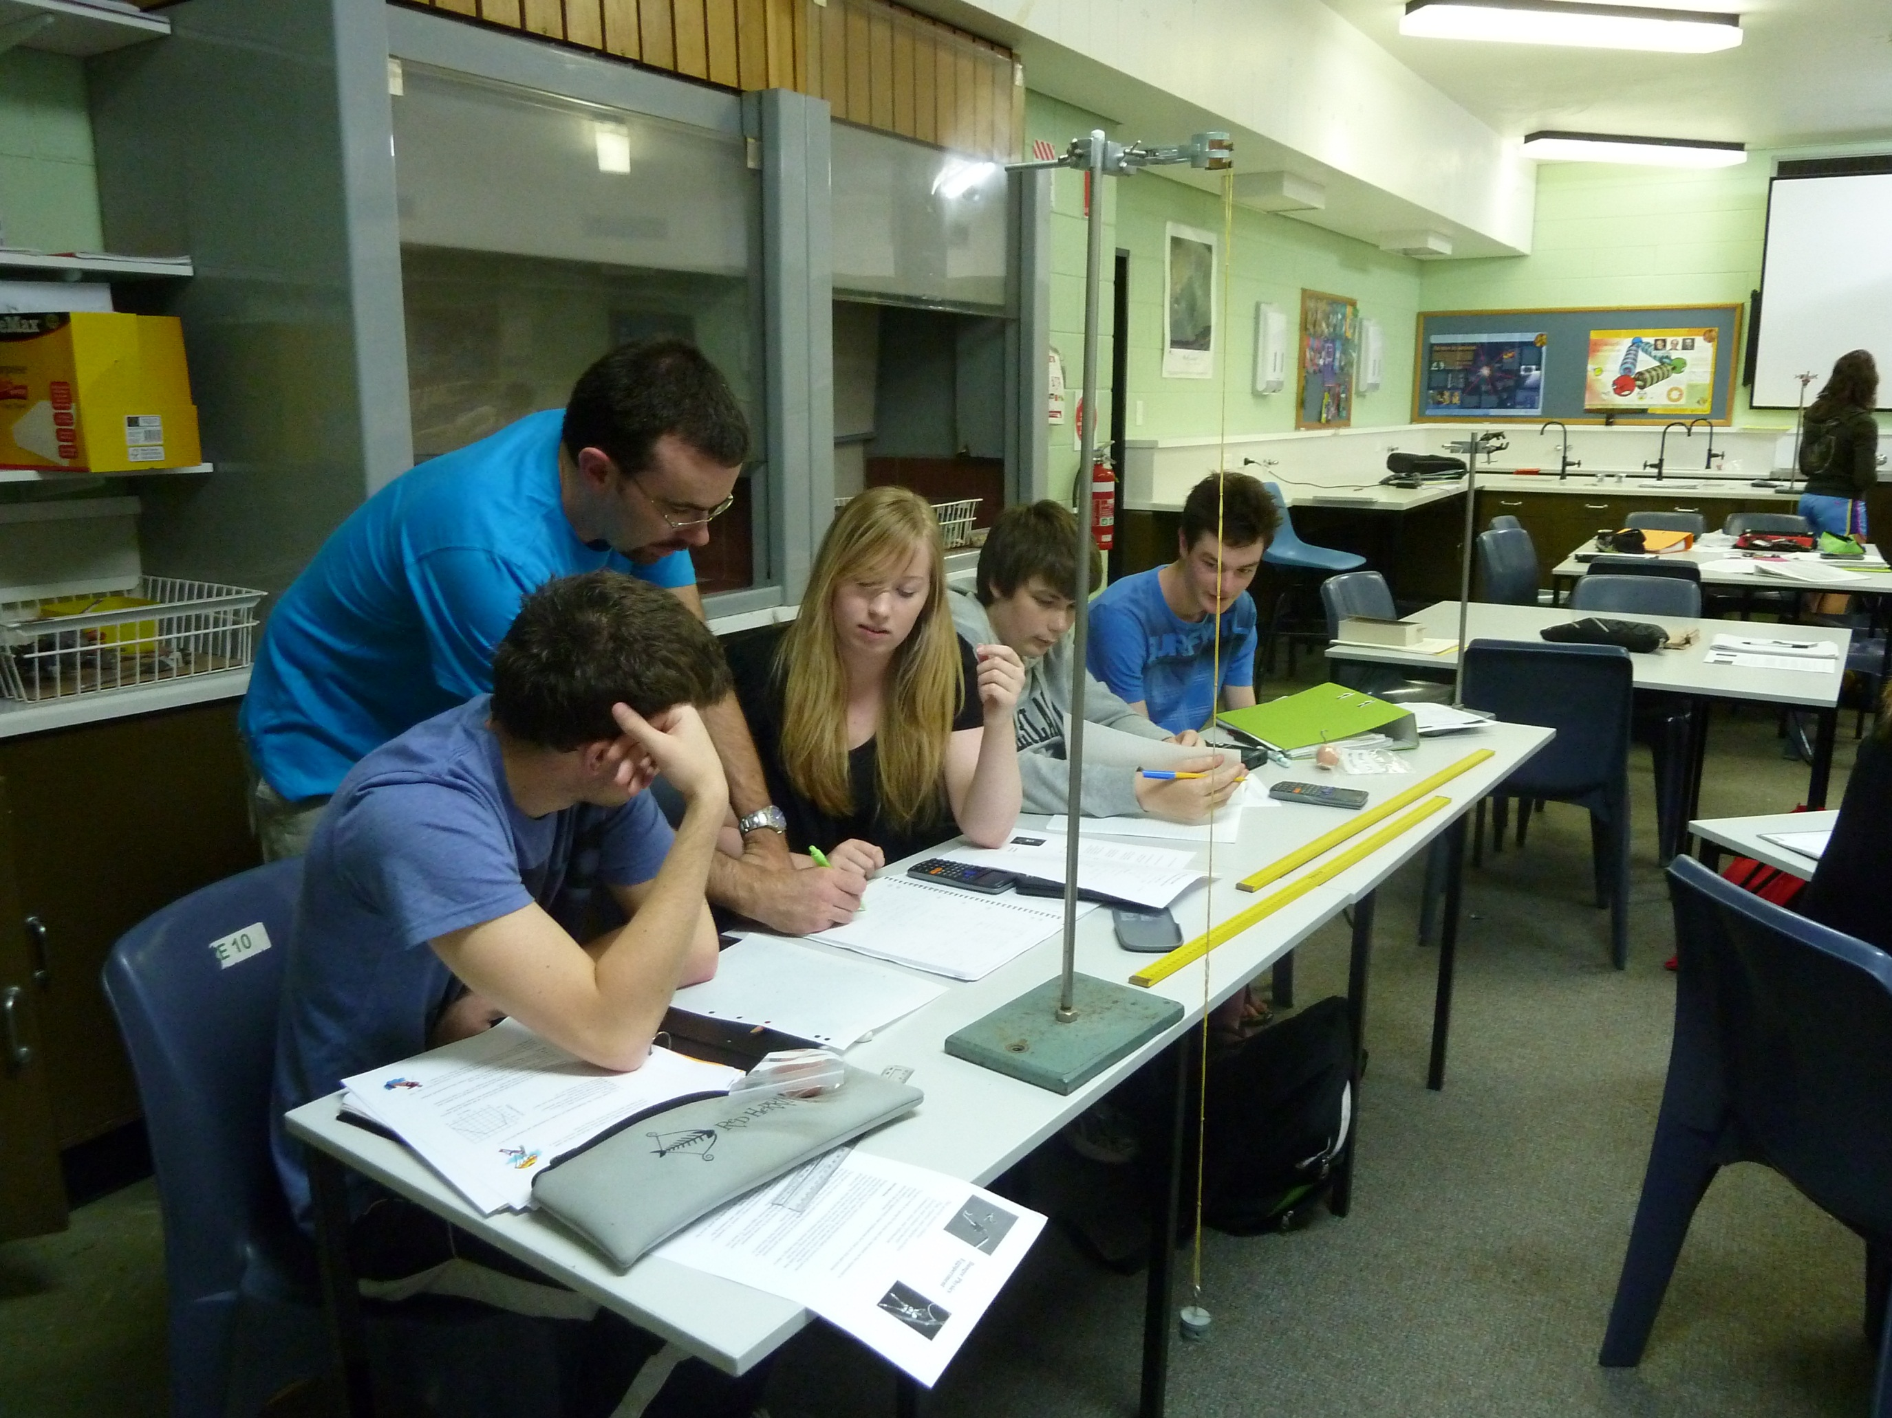*Hellyer College*

*School Improvement Plan*

*2016-2020*

**Our Mission** - *Hellyer College provides students with the opportunity to continue to learn and reach their potential, to lead fulfilling and productive lives and to contribute positively to the community*

**Vision** – *Through rich learning opportunities, our college community develops successful, qualified and skilled young people to succeed in further education, training or employment beyond Year 12*



Department of Education

Hellyer College

Version 9.0 – 18 May, 2015

**Hellyer College Strategic Plan 2016-2020**

2016/2017 focus

**Our Core Values:**

* ***High Expectations***- We empower all students and staff to achieve and celebrate their personal best through high expectations
* ***Relationships***– We build positive relationships with students, staff and the community
* ***Creativity*** – We encourage creativity in everyone; this is the cornerstone which fosters curiosity, experimentation, innovation, inspiration and connected learning
* ***Learning*** – We provide a learning environment that is collaborative, innovative and relevant
* ***Respect*** *– We respect and care for each other and our environment*
* ***Resilience***– We show our resilience as we learn from our mistakes and use the opportunity to improve; building a sense of determination and optimism when faced with challenges
* ***Integrity***- Integrity drives all of our decision making, underpins all learning experiences and is the hallmark of staff and student relationships

|  |  |  |  |  |  |
| --- | --- | --- | --- | --- | --- |
| Our Drivers | Successful Learners | Innovative workforce | Inspired Leadership | Dynamic Learning environments | Community Confidence |
| * Empower learners to set high expectations about their education and future aspirations. * All students have the opportunity to gain ‘everyday adult’ skill sets in Literacy, Numeracy and ICT * Engage students through creative, innovative and supported learning. * Establish safe, flexible and engaging learning environments * Develop 21st century skills and independent learning principles. * Establish enrichment programs and holistic learning programs to enable students to contribute to their community. | * Create a culture of continuous improvement * Create a highly qualified and motivated workforce through strategic professional learning * Develop strong systems and structures to support staff and students * Implement strategies to enhance the health and well-being of staff * Provide staff with regular feedback on their performance * Enable staff to enhance their professional practice. | * Promote a culture of inspiring leadership for all staff * Provide professional learning, coaching and mentoring for all staff * Encourage a culture of innovation and continuous improvement. * Enhance leadership development and performance management across the DoE. | * Work collaboratively with TasTAFE, Flexible Learning Network, ASbA etc. to support the pathways and needs of our learners. * Work with all our associated high schools, in particular with our rural schools, to support the co-delivery of Year 11/12 programs in their schools. * Utilise the work of Zbar and Masters to ensure dynamic learning environments * Support professional learning through the PLI. | * Use data to inform our practice that is measurable and focussed on continuous improvement * Develop strong communication processes with the community about the work of Hellyer College * Celebrate student achievement with our associated schools, TasTAFE, UTas and our community. * Provide meaningful feedback and reports to parents about student progress. * Encourage community involvement at Hellyer College |

|  |  |  |  |  |  |
| --- | --- | --- | --- | --- | --- |
| Our Priorities  Our Priorities | Ensuring Purposeful Pathways and Successful Transitions | Fostering High Quality Teaching | Encouraging High Attendance and the Successful Completion of Year 12 (gain TCE) | Improving Student Qualifications | Implementing National and State Curriculum Initiatives |
| * Strong partnerships with our associated high schools * Strong connections with industry, UTas, TasTAFE and other VET providers. * Career education and pathway planning for all students * Comprehensive orientation and course selection process for all students * Effective and targeted transition processes for all students | * Support collegial networks and Learning Area Teams * Implement PDPs using coaching model * Ensure the ‘preconditions for learning’ are in place (Zbar) * Differentiated Professional Learning for staff linked to college goals * Utilisation of Good Teaching support documents * Utilise DoE systems and structures e.g. Edi, SSS | * Whole college focus on improving attendance and retention * Student support staff work to support the work of teachers * Senior Staff (Pr/APs) working with students with attendance issues * Tracking of selected students * Provide alternative learning programs for disengaged students. * Extra support for rural students | * Ensure all students achieve either a vocational qualification or an ATAR. * Ensure all students have an opportunity to achieve the TCE. | * Support course development work with TASC * Enhance teachers knowledge and understanding of new curriculum content * Encourage the development of contemporary teaching strategies within the context of new curriculum initiatives. * Work with our associated high schools to ensure seamless curriculum delivery for students. |

**Hellyer College Operational Plan 2016**

|  |  |  |  |  |  |
| --- | --- | --- | --- | --- | --- |
| **Priority 1- An explicit improvement agenda** | | | | | |
| **Our Targets** | **Data** | **Strategies** | | **Resources** | **Measures of success** |
| Develop a strong culture of continual improvement  Ensure preconditions for improvement (Zbar) are in place:   * *Strong leadership that is shared* * *High levels of expectation and teacher efficacy* * *Orderly learning environments where students are well known* * *Focus on what matters most* | National School Improvement Tool was utilised in March 2015  **Revisit the areas we highlighted in March and be more explicit in what the data is telling us – for all 9 domains – Jan 2016 | All members of Leadership Team – Pr/APs/ASTs/SBM/Admin Band 3 –Leadership PL with Dianne Henning (Growth Coach)  All college leaders focus on implementing SIP  Explicit use of Learning Area meetings to implement SIP  Explore Culture Development through LSI 360 degree process | | $ to engage in 4 days PL with Dianne Henning (Growth Coach)  $ to implement LSI culture tool through PLI | National School Improvement Tool data will show improvement across all priority areas  Student satisfaction data  Staff satisfaction data  Parents satisfaction data |
| **Priority 2- Analysis and discussion of data** | | | | | |
| **Our Targets** | **Data** | | **Strategies** | **Resources** | **Measures of success** |
| Staff to utilise Doc Point data on an ongoing basis:   * Student History Report * TCE Projections report   Staff to utilise Edi data on a regular basis | Data walls to beginning to be created and used. | | Analyses K-10 data and use to inform course choices in Gr 10  Use TCE projections data in MyEducation/Support Group  PL for all staff in Jan 2016, with class list to support teachers  PL sessions to discuss data and plan for student improvement | EPS/Doc Point data  PL for all senior staff and 3x admin staff in Edi/SSS – Nov 2015  TASC data | 100% of staff indicate they use data to inform teaching and learning  Data walls are seen in staff room and classrooms  >85% attendance rate  Less course changes |
| **Priority 3- A culture that promotes learning** | | | | | |
| **Our Targets** | **Data** | | **Strategies** | **Resources** | **Measures of success** |
| The ‘tone’ of the school reflects a school-wide commitment to purposeful, successful learning, underpinned every day by our Core Values  Develop consensus on ‘what is good teaching?’ and begin feedback class walkthroughs – new Policy/Procedure  All students will be engaged in challenging, meaningful learning  All students will be expected to learn successfully, in their own ways and at their own pace | **2015 Data -**  69% of students did at least one TASC Level 3 (increase)  50% of students did at least four TASC Level 3 subjects (same)  70% of students did some VET subjects (decrease)  63% of students achieved their TCE (increase)  38% of students achieved an ATAR (decrease)  Average daily attendance (Edi) was 77% | | Use the *Respectful Schools Respectful Behaviour* support document to develop policy and procedures  Practice measures of restorative justice model  Staff will have clearly articulated, taught and modelled expectations in regards to learning, use of mobile phones and attendance to all classes. Consequences will be consistent and documented in SSS  Implement MGM texting to parents re attendance by 3pm each day  Investigate alternative timetabling e.g. 5 lines  ICT tick into Year 12 Support Group – include in courses where possible  Greater awareness during transition process. Include in Year 11 to 12 transition processing | Whole school PL  $3000  TCE Planner  New Year 11 to 12 form | Less behavioural issues in classrooms – BM takes up little time  Daily attendance of students will increase to 85%  Increase number of students who achieve their TCE at the end of Year 12  Increased number of students gaining an ATAR  Increased number of students gaining the TCE  Increased number of students gaining a VET qualification |
| **Priority 4- Targeted Use of School Resources** | | | | | |
| **Our Targets** | **Data** | | **Strategies** | **Resources** | **Measures of success** |
| Capital Work grant to develop whole college to better support 900 students and over 100 staff  Development of college Policies and Procedures to support student learning  Budget Plan will reflect strategic and transparent use of resources | The college has not had any major works since 1970  Some classrooms are too small and unsafe | | Submit Capital Works application (Dec 2015); (May 2016)  School Association to invite the Minister to visit  The school Leadership Team will introduce strategies for early identification (Term 1) of student needs and resources for successful learning outcomes  Administrative Manager will develop clear Budget Plan, in consultation with LA Leaders |  | Visit from the Minister  Notification of Capital Works funding – upgrade as opposed to duplicating services  Teachers will feel confident, happy and competent to implement differentiated programs  Positive outcomes for students will be achieved – students will know their requirements, clear boundaries which will lead to students being happy, confident and safe |
| **Priority 5- An expert teaching team** | | | | | |
| **Our Targets** | **Data** | | **Strategies** | **Resources** | **Measures of success** |
| A culture of coaching/mentoring will be developed  PDPs will continue to be refined – focus on personal and college goals  Roles and responsibilities of all staff will be clearly defined and documented | 2015 – focus on whole school PL  15% of teachers in 2015 voluntarily ask for explicit feedback and classroom walkthroughs  More accountability in 2015 in regards to PDPs | | Identify PL that is explicitly focussed on improving student learning outcomes  Formalise a process for observations of colleagues – Develop a buddy system within own Learning Area  Document all staff roles and responsibilities by June 2016 | Time to access expertise across colleges  Increase time available to complete and review PDPs | Increased teacher confidence/self-efficacy with subject content  Greater range/more varied strategies in the toolkit of teaching  Improved teaching and learning outcomes – explicit data collected from observations  All staff will be aware of the R and R of all staff |
| **Priority 6- Systematic curriculum delivery** | | | | | |
| **Our Targets** | **Data** | | **Strategies** | **Resources** | **Measures of success** |
| Curriculum delivery will reflect our college vision of “*through rich learning opportunities, our college community develops successful, qualified and skilled young people to succeed in further education, training or employment beyond Year 12”*  Curriculum delivery will be flexible and cater for a wide variety of students  Our reporting processes are rigorous and provide students and parents with relevant, timely information |  | | Examine a variation to the current time-table that < ‘free blocks’  Whole college planning of curriculum – maybe unpack suitable subjects from different learning areas  Reflect on current subject offerings – what can we add/remove?  Use pathway maps for the community and students – Year 11/12/beyond  Learning Area meetings will explicitly focus on continual improvements for all students | More time to meet with CTLs  Conversations with UTAS about building aspirations of students | Course changes will decrease due to better mapping  Increase in attendance  Stronger connections with UTAS  Increased student attainment |
| **Priority 7- Differentiated teaching and learning** | | | | | |
| **Our Targets** | **Data** | | **Strategies** | **Resources** | **Measures of success** |
| Teachers will use data to ensure they know their students and understand their students’ needs |  | | Utilise assessment tools early in Term 1  Access data from secondary schools earlier  Utilise the *Good Teaching Differentiated Classroom Practice Learning for All s*upport document |  | Teachers will have a better understanding of student abilities before they enter Year 11  Teacher planning will reflect the different needs of students/groups  Parental feedback about reports will be positive |
| **Priority 8- Effective pedagogical practices** | | | | | |
| **Our Targets** | **Data** | | **Strategies** | **Resources** | **Measures of success** |
| Teachers will clearly articulate what students are expected to learn in each of their classes  Feedback to students will be timely  Students will be able to articulate what they are learning, and why, and how they intend to improve | Student survey data reflects a decrease in regards to feedback from teachers  Some staff indicate this occurred in 2015  100% of staff have a PDP | | Utilise the *Good Teaching Quality Assessment Practices Guiding Learning s*upport document  Implement Data Walls in classrooms  School leaders will visit classrooms at least 1x year and provide feedback/discussion  PL will support continuous improvement in regards to pedagogical content knowledge | Time for class visits  Time for staff to meet  MyEducation  PL with outside experts  Additional support for students with low level literacy/numeracy | Student survey results will indicate an improvement in regards to teacher feedback  All staff will be involved in class visits by school leaders  All staff will have their PDPs signed off – increased accountability for achieving goals  All staff on board with MyEducation  Increased number of students will attend all classes – Edi data |
| **Priority 9- School-Community Partnerships** | | | | | |
| **Our Targets** | **Data** | | **Strategies** | **Resources** | **Measures of success** |
| Increased parent/family involvement  Increase partnerships/connections with local businesses and community | Previously –  ‘Thank you’ breakfasts/cocktail party for industries who support our students  BCC Industry day  Community visits | | Review our reporting systems – e.g. . students and parents to come in to meet and collect reports  . Parent/Teacher interviews involve students, have them in classrooms  Newsletter/Schoolzine – emails, send to businesses, run Business 3  Possibly connect with Beacon, Rotary Lions re mentoring programs | $$ to continue to have a Careers Teacher/Officer | Increased transparency/sharing of industry visits/excursions with all staff |